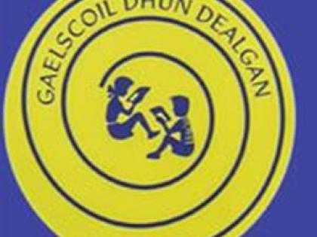 Gaelscoil Dhún Dealgan
Leabhar Liosta
Naí Mhóra 2021-2022
Le fáil sa scoil
Please do not buy any of the following items.
Everything on this list is provided by the school

Séideán Sí  Mo Leabharsa B  Ag Obair Liom B | € 10.00
Leabhar Oibre Starlight | €10.00
Sounds Make Words (42 sounds) | €7.00
Scríobh Liom B | €7.00
Gafa le Mata | €10.00
Fillteán | €2.00
Filteán Obair Bhaile x2 | €2.00
Cóipleabhair:  Project book 15x3  Junior Sum Copyx1  1 x A11  (Saorscríbhneoireacht) | €4.00
Fótachóip / Ealaín | €20.00
Léitheoirí Gaeilge / Béarla | €5.00
IOMLÁN | €77.00

Please make sure that you label all your child’s belongings clearly with his/her name as Gaeilge (as written on your child’s school report).
Billí leabhair le bheith íoctha go hiomlán roimh dheireadh Mhí Mheán Fómhair.
Book bills are to be paid using the Easy Payments Plus button on our school website before the end of September.

