While social media may help raise awareness, it can also provide misinformation. It is very easy to become overwhelmed while scrolling through headline after headline. Remember to limit time spent on social media and try out alternative activities instead.

Exercise is good for your body but great for your mind too!
Exercising for even 15 minutes can boost our mood, relieve tension and stress and improves sleep.
- Why not turn up the radio and dance around the kitchen with the kids – they will love this! Just Dance have a Youtube channel for kids
- Many gyms and personal trainers are uploading workouts to Youtube and Facebook. (Rinka are uploading a daily video at 9 o’clock for kids)
- Google 15 minute HIIT exercises.
- Why not try yoga or meditation together. Some examples include
Cosmic Kids Yoga, New Horizon Meditation, Go Noodle
- 10 @ 10 on RTE Junior have lots of fun exercises for children

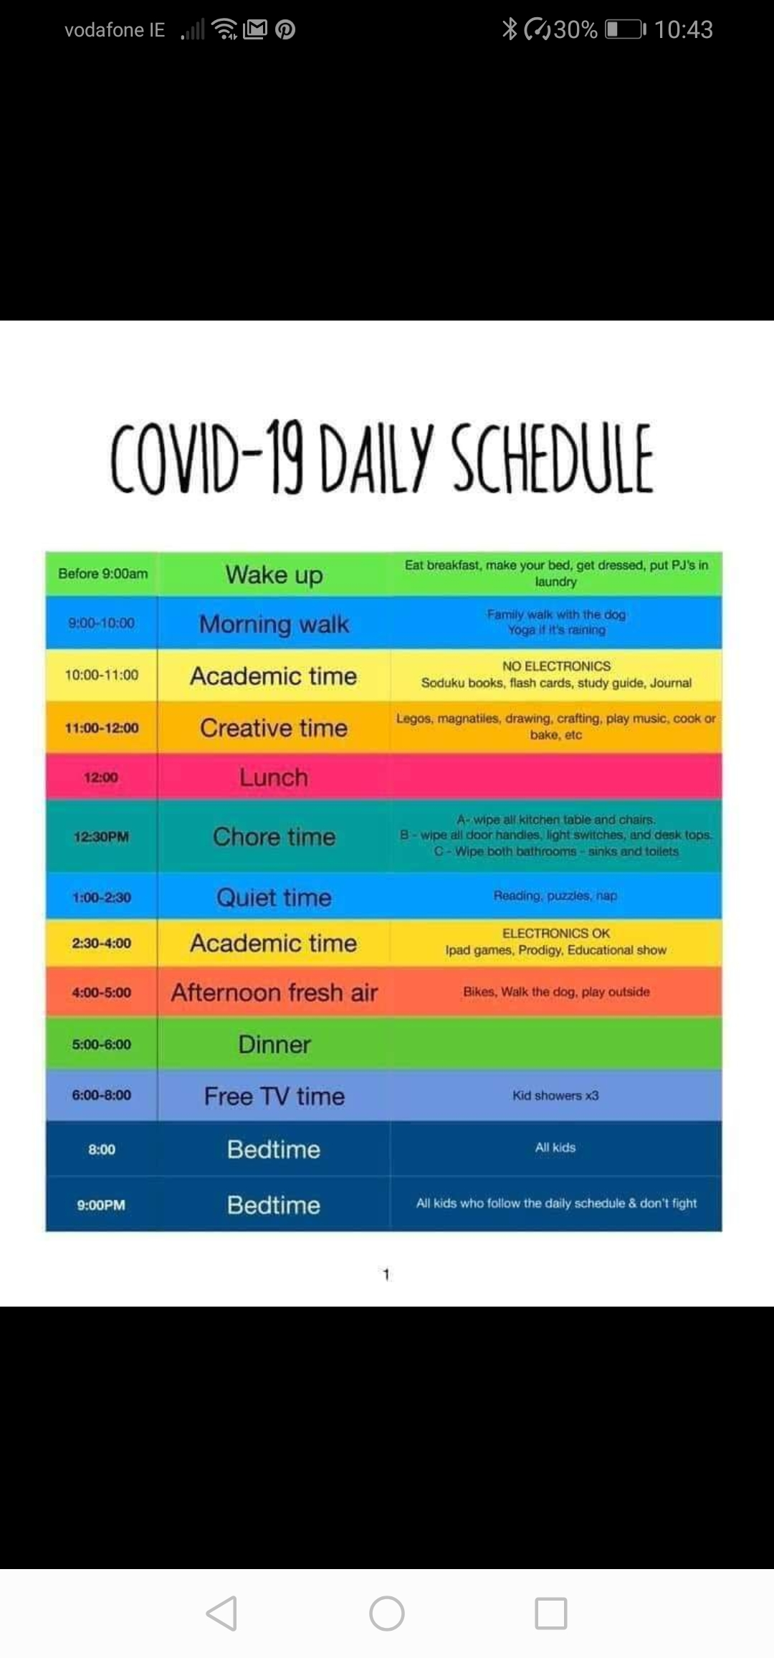

We all need structure and it is really important that we try to maintain a routine where possible.
Why not get the kids involved when establishing a schedule like the one above? Have a set area where children can do their work and always start with the most difficult subject. This may be best in the morning time when they are at their freshest.
Why not tackle some jobs around the house? Order some new candles, clear out those cupboards, sort out toys, print and frame some photos….

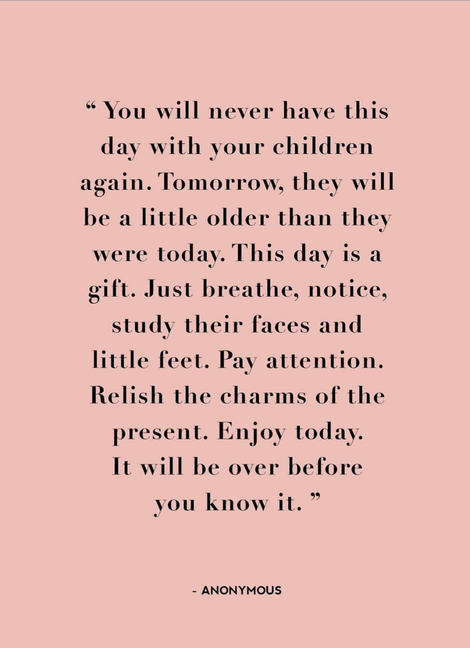
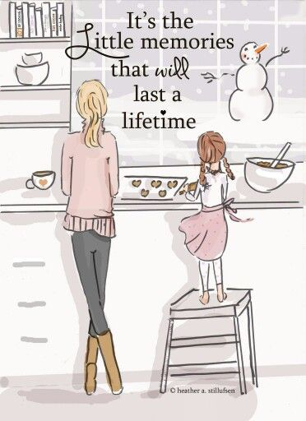
Life is what you bake it!
Homemade Fruit Scones  900g Self Raising Flour  225g Butter  Sultanas  80g Caster Sugar  2 eggs  Milk  Method:  - Preheat oven to 200⁰C (Fan oven 200/Gas Oven Mark 7)  - Sieve flour into bowl  - Rub in butter until mixture looks like breadcrumbs  - Add sugar and sultanas and stir  - Add in eggs and enough milk to bring the mixture together  - Sprinkle some flour on the table and gently knead the dough to remove any cracks  - Roll out the mixture and use a cutter to cut the scones (about 1 inch thick)  - Flour a baking tray and place the scones on it. Lightly brush each scone with milk and bake in the oven for 10-12 minutes until well-risen and golden. | - Cupcakes  - 75g (6oz) self-raising flour  - 110g (4oz) caster sugar  - 1tsp baking powder  - 2 large eggs  - 110 g soft margarine or butter softened and cut into small pieces  - 50 ml milk or water  - for the buttercream frosting:  - 150 g butter, softened  - ½ tsp vanilla extract (optional)  - 275 g icing sugar, sifted  - Method:  - 1. Preheat the oven to 180°c (Gas mark 4) and line the bun tray with paper cases.  - 2. In a large bowl, combine all the dry ingredients. Make a well in the centre of the bowl then break in the eggs and add the margarine or butter.  - 3. Using an electric hand mixer beat all the ingredients together until combined.  - 4. Pour in half the milk or water and beat again until combined. You are looking for the batter to be light and creamy. Add the rest of the liquid if you need it – you may not.  - 5. Divide the batter evenly among the paper cases and bake in the oven for 15-20 minutes or until firm and light brown on top.  - 6. Allow the cupcakes to stand for a minute before transferring to a wire rack to cool.

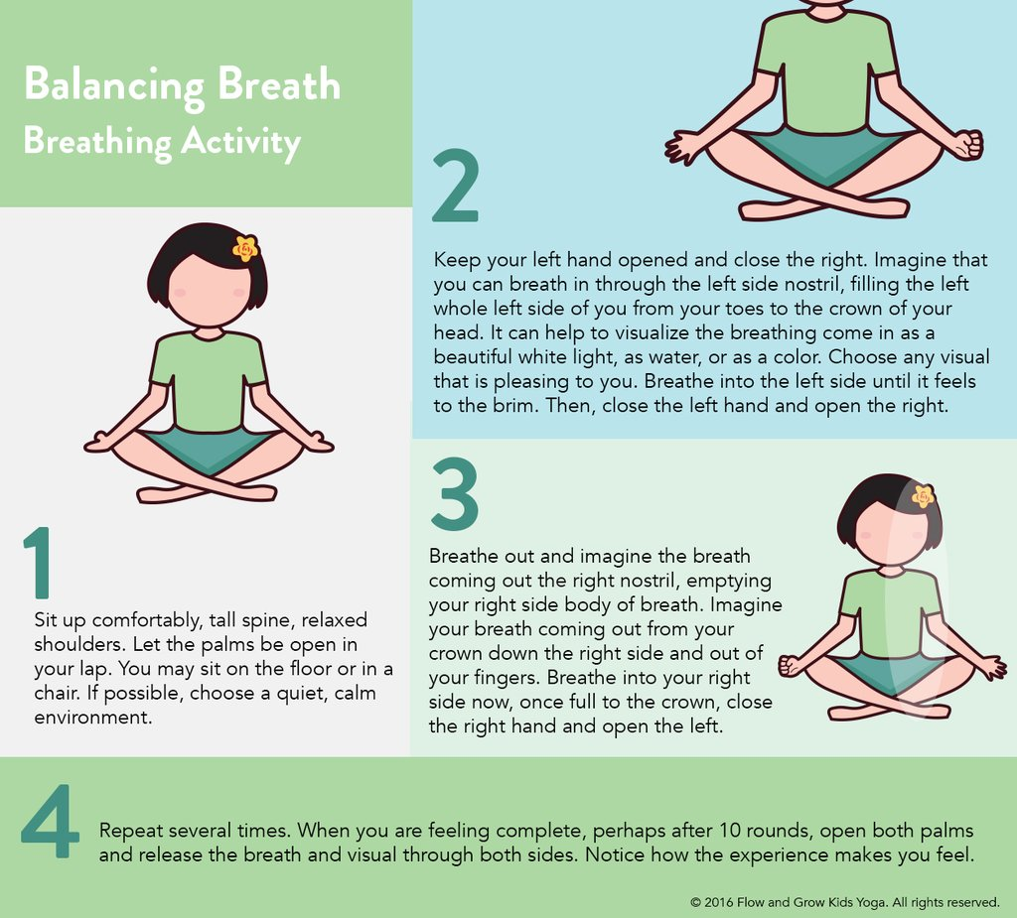
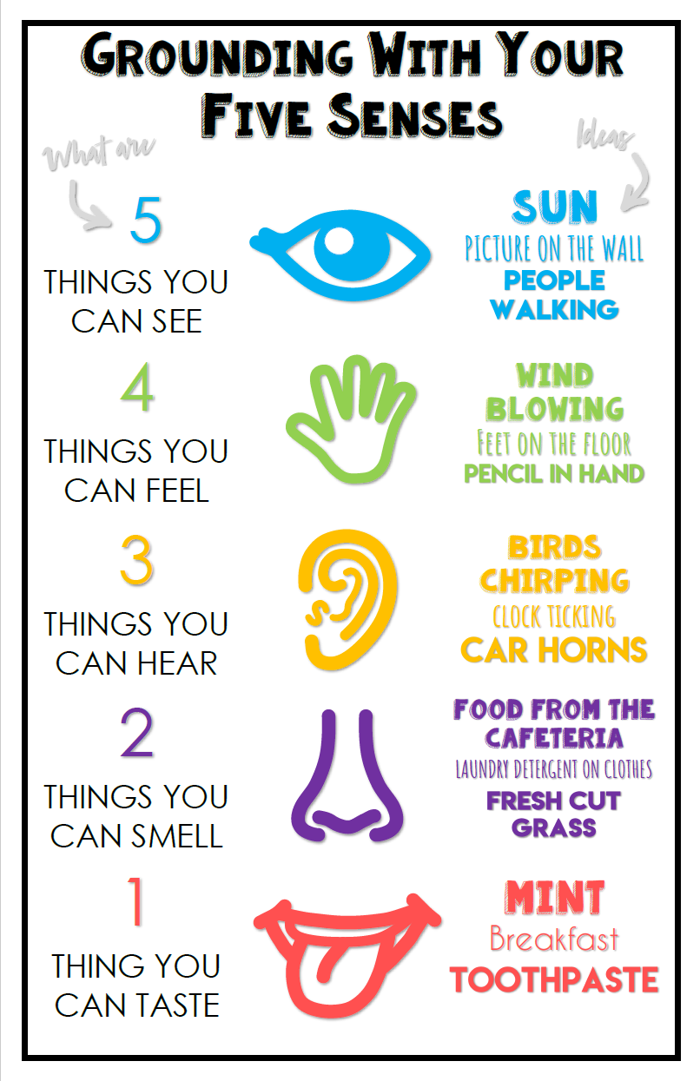
Useful Information and Contacts:
www.hse.ie
https://www2.hse.ie/conditions/coronavirus/coronavirus.html

Helplines:
Senior Line can be contacted on 1800-80-45-91. (Helpline for elderly)
ALONE is also offering coronavirus advice on 0818-222-024.
The Health Service Executive can be contacted on 1850-24-1850
Income Supports:
A number of income supports are available from the Department of Employment Affairs and Social Protection for your employees during a COVID-19 (Coronavirus) related absence or temporary lay-off from work:
- employees and the self-employed who have lost employment due to a downturn in economic activity caused by the COVID-19 pandemic.
- workers who are not diagnosed with COVID-19 but who self-isolate
- workers whose employers do not supplement/top-up the State Illness Benefit payment (COVID-19)
- workers who are requested to stay at home by their employer (COVID-19)
- workers who are laid off temporarily or put on to short time working (COVID-19)
- workers who need to take time off work to care for a person affected by COVID-19 (Coronavirus)
see www.gov.ie for printable forms and more information

Remember this too will pass!
Tabhairígí aire,
Múinteoir Cristíona
(087) 170 6488

