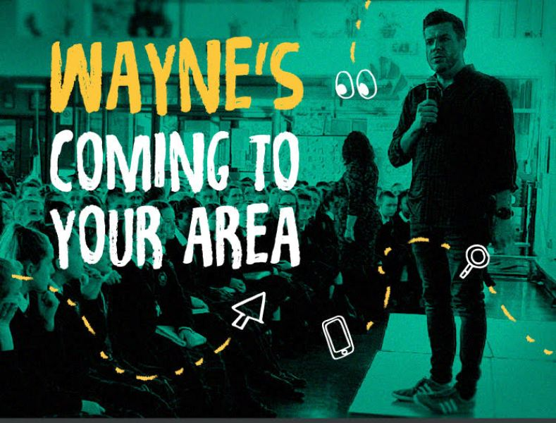

**Tá Wayne Denner, an ‘Digital Ninja’ ag teacht!**

**Ná caill é!**

**Don’t miss this talk for parents from Ireland’s leading expert on online safety!**

**

Cén uair/When? Dé Máirt/Tues 5/2/19

**Cén t-am/What time? 7 a’chlog/ 7 p.m.**

**Cén áit/Where? Halla na Scoile**

**Author** of '**The Student's Guide to an Epic Online Reputation..and parents too,**', **RepSelfie App Inventor, Educator, Entrepreneur,  Speaker and Trainer,** Wayne Denner set up Ireland's first Social Network platform in the early noughties before Facebook, Twitter, Myspace and Bebo!.  Wayne has now 20 years experience and is internationally regarded as a thought leader and influencer on online safeguarding, youth engagement online and emerging trends in today's rapidly changing online environment.

Wayne inspires and motivates young people and adults to protect their well being online, take control and maximise their individual talent in today's digitalworld. Wayne tells his storyand provides sound advice on protecting personal, professional and organisational reputation online and using social networks, the internet and smartphones to your advantage.

Wayne works with

**RADIO ONE, BBC, BBC Radio Ulster, Canadian Senate, Bauer Media Group, NI Assembly, Politics Plus, PHA, ISM UAE, NAHT, ASCL, NITB, WHSCT, SHSCT, NHSCT, NISP, DEL, BT Ireland, Legal Island, NSPCC, Children in N Ireland, Children in Action, CYPSP, RADAR, PSNI, PCSP, Neighbourhood Renewal, Volunteer Now, Belfast Central Mission, VOYPIC, Start 360, YPP, Queens University Belfast, University of Ulster, NWRC, NRC, SRC, GAA, Kinship Care, Strengthening Families and many other Statutory, charitable, voluntary, community and business organisations and schools. Wayne Denner delivers events and training for professionals, educators, families and audiences in Ireland, the UK and UAE.**

**Wayne currently talks with upwards of 50,000 students per year - as well as thousands of parents, teachers and business/community leaders.**

